# PRACTICAL 6

**Aim:**

1. Create login application where you will have to validate EmailID (UserName).

Till the username and password is not validated, login button should remain disabled.

1. On successful login,go to on new Acticity.

**Design:**

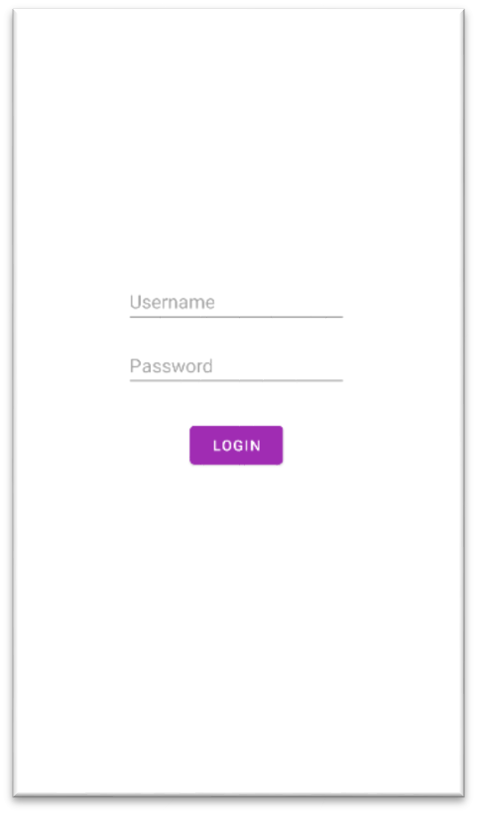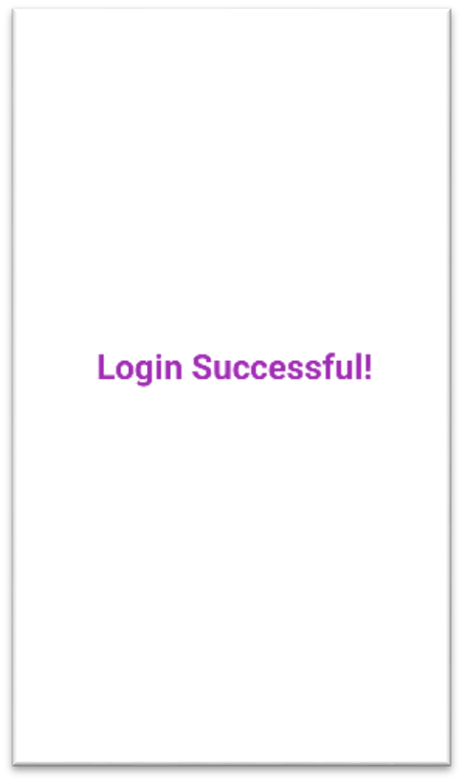

**Code:**

|  |
| --- |
| package com.example.prac61;    import androidx.appcompat.app.AppCompatActivity;  import android.content.Intent; import android.os.Bundle; import android.text.Editable; import android.text.TextWatcher; import android.view.View; import android.widget.Button; import android.widget.EditText;  public class MainActivity extends AppCompatActivity {  EditText uname, pwd;  Button login; @Override  protected void onCreate(Bundle savedInstanceState) { super.onCreate(savedInstanceState); setContentView(R.layout.*activity_main*); uname = findViewById(R.id.*username*); pwd = findViewById(R.id.*password*); |
| login = findViewById(R.id.*login*); uname.addTextChangedListener(textWatcher); pwd.addTextChangedListener(textWatcher);  login.setOnClickListener(new View.OnClickListener() {  @Override  public void onClick(View view) {  Intent intent = new Intent(MainActivity.this, SuccessActivity.class);  startActivity(intent);  }  });  }  TextWatcher textWatcher = new TextWatcher() {  @Override  public void beforeTextChanged(CharSequence charSequence, int i, int i1, int i2) {    }    @Override  public void onTextChanged(CharSequence charSequence, int i, int i1, int i2) {    }    @Override  public void afterTextChanged(Editable editable) { check();  }  };  private void check() {  if(uname.getText().toString().equals("Yatharth") && pwd.getText().toString().equals("Yatharth")){ login.setEnabled(true);  } else{  login.setEnabled(false);  }  }  } |

**MainActivity.java**

**SuccessActivity.java**

|  |
| --- |
| package com.example.prac61;  import androidx.appcompat.app.AppCompatActivity;  import android.os.Bundle;    public class SuccessActivity extends AppCompatActivity {  @Override  protected void onCreate(Bundle savedInstanceState) { super.onCreate(savedInstanceState); setContentView(R.layout.*activity_success*); }  } |

**Output:**

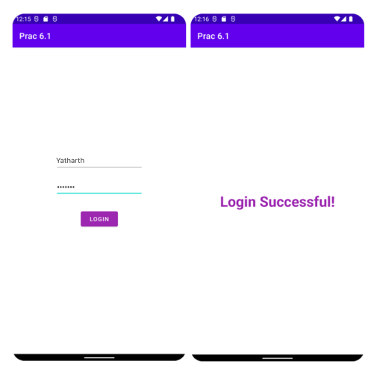

# PRACTICAL 7

**Aim:** Create an application to make a Phone call on specific entered number by user in the EditText.

**Design:**

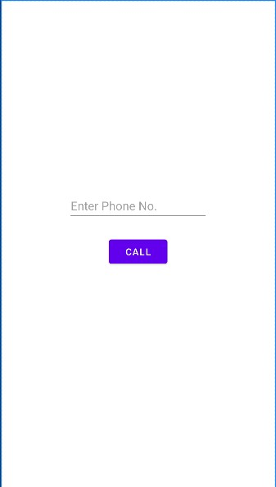

**Code:**

package com.example.prac7;

import androidx.appcompat.app.AppCompatActivity;

import android.os.Bundle;

import android.content.Intent; import android.net.Uri; import android.os.Bundle; import android.view.View; import android.widget.Button; import android.widget.EditText;

public class MainActivity extends AppCompatActivity { private EditText t1; private Button bt1;

@Override

|  |
| --- |
| protected void onCreate(Bundle savedInstanceState) { super.onCreate(savedInstanceState); setContentView(R.layout.*activity_main*); t1=findViewById(R.id.*editText*); bt1=findViewById(R.id.*button*);  bt1.setOnClickListener(new View.OnClickListener() {  @Override  public void onClick(View view) {  String num=t1.getText().toString().trim(); Intent intent=new Intent(Intent.*ACTION_CALL*, Uri.*parse*("tel:"+num));  startActivity(intent);  }  });  } |

**Output:**

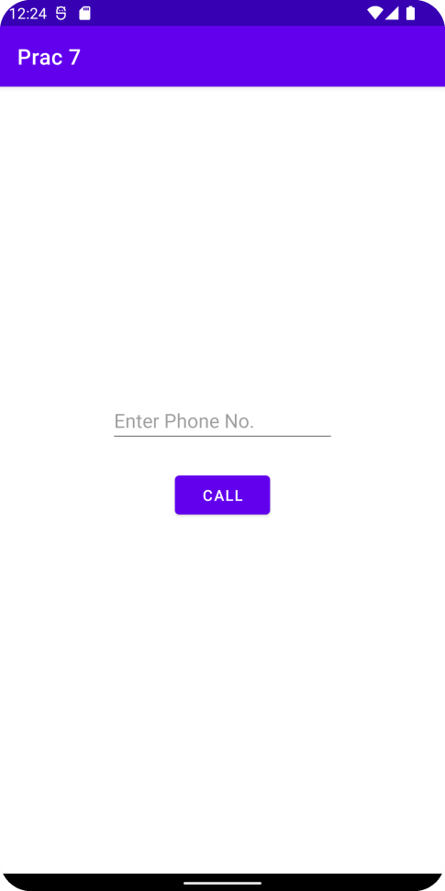 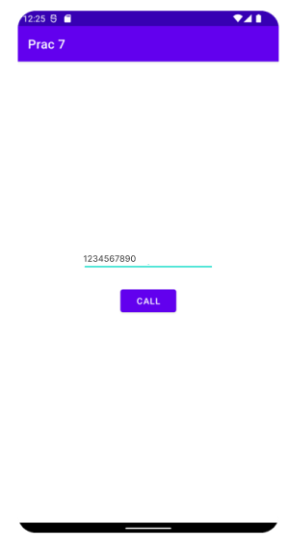

# Practical 8.1

**Aim:** Create an Android Application where user will enter the destination email address, subject and a message. On clicking Send button, it will prompt email client only and email will compose. Also put some logic over EditText field that no one fields are empty otherwise notify with toast.

**Design:**

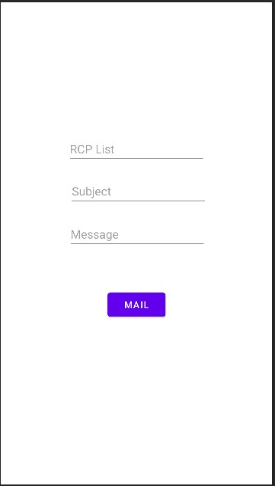

**Code:**

|  |
| --- |
| package com.example.prac8;    import androidx.appcompat.app.AppCompatActivity;    import android.content.Intent; import android.os.Bundle; import android.view.View; import android.widget.Button; import android.widget.EditText;  public class MainActivity extends AppCompatActivity {  EditText et1, et2, et3;  Button btn;    @Override  protected void onCreate(Bundle savedInstanceState) { super.onCreate(savedInstanceState); setContentView(R.layout.*activity_main*); et1 = findViewById(R.id.*editText*); et2 = findViewById(R.id.*editText2*); et3 = findViewById(R.id.*editText3*); btn = findViewById(R.id.*button*); |
| btn.setOnClickListener(new View.OnClickListener() {  @Override  public void onClick(View view) {  String rcplist = et1.getText().toString();  String[] rcp = rcplist.split(",");  String sub = et2.getText().toString();  String msg = et3.getText().toString(); Intent i = new Intent(Intent.*ACTION_SEND*);  i.putExtra(Intent.*EXTRA_EMAIL*, rcp);  i.putExtra(Intent.*EXTRA_TEXT*, msg);  i.setType("message/rfc822");  startActivity(Intent.*createChooser*(i, "Choose Email  Client"));  }  });  }  } |

**Output:**

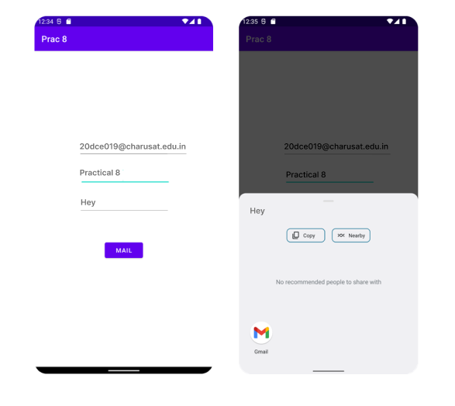

# Practical 8.2

**Aim:** Create an Application in which user pass the data with intent object to another activity.

**Design:**

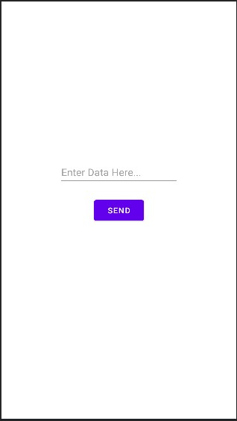

**Code:**

**MainActivity.java**

|  |
| --- |
| package com.example.prac82;    import androidx.appcompat.app.AppCompatActivity;  import android.os.Bundle; import android.content.Intent; import android.view.View; import android.widget.Button; import android.widget.EditText;    public class MainActivity extends AppCompatActivity {    EditText et1;  Button b1; @Override  protected void onCreate(Bundle savedInstanceState) { super.onCreate(savedInstanceState); setContentView(R.layout.*activity_main*); et1=findViewById(R.id.*data*); b1=findViewById(R.id.*button*);  b1.setOnClickListener(new View.OnClickListener() {  @Override  public void onClick(View view) {  String data1=et1.getText().toString();  Intent intent=new  Intent(MainActivity.this,MainActivity2.class); intent.putExtra("dt",data1); startActivity(intent);  }  });  } } |

**MainActivity2.java**

|  |
| --- |
| package com.example.prac82;    import androidx.appcompat.app.AppCompatActivity; import android.os.Bundle; import android.content.Intent; import android.widget.TextView;    public class MainActivity2 extends AppCompatActivity {  TextView t1; @Override  protected void onCreate(Bundle savedInstanceState) { super.onCreate(savedInstanceState); setContentView(R.layout.*activity_main2*);  t1=findViewById(R.id.*textView*);  Intent intent=getIntent();  String test=intent.getStringExtra("dt"); t1.setText(test);  }  } |

**Output:**

